Michael E. Cohen

Residents

Research Day

State University of New York at Buffalo, Department of Neurology, Jacob’s School of Medicine and Biomedical Sciences

2016

Friday, June 10, 2016 11:30 am—4:00 pm Cummings Conference Center

Graduating Residents

Farid Din, MBBS Lindsay Dudeck, M.D.

Child Neurology, PGY5 Child Neurology, PGY5

Haris Kamal, M.D. Arangzeb Memon, MBBS

Adult Neurology, PGY4 Adult Neurology, PGY4

Co-Chief Resident Co-Chief Resident

Adnan Khan, MBBS Emily Langan, M.D.

Adult Neurology, PGY4 Child Neurology, PGY5

(Graduating January, 2017)

Mahmoud Abdelrazek, MBChB

Adult Neurology, PGY4

PGY III Residents 2015-2016

Ashish Arora, M.D. Svetlana Primma-Eckert, MD

Adult Neurology, PGY3 Adult Neurology, PGY3

(incoming Co-Chief) (Incoming Co-Chief)

Rabia Ghazi, MBBS Hao Cheng, M.D.

Adult Neurology, PGY3 Adult Neurology, PGY3

David Okonkwo, M.D Alok Singla, MBBS

Child Neurology PGY3 Child Neurology, PGY3

Brian Trummer, M.D.

Adult Neurology, PGY3

PGY II Residents 2015—2016

Muhammad Ahmed, MBBS Harshit Shah, MBBS

Adult Neurology, PGY2 Adult Neurology, PGY2

Varun Sreenivasan, MBBS Daniela Zambrano, M.D.

Adult Neurology, PGY2 Adult Neurology, PGY2

Sandhya Mehla, MBBS

Adult Neurology, PGY2

State University of New York at Buffalo,

Department of Neurology,

School of Medicine and Biomedical Sciences

Welcome/Introduction

11:30 am Gil I. Wolfe, M.D., FAAN

Robert Zivadinov, MD, PhD, FAAN

Nicholas J. Silvestri, M.D.

Presentation Session # 1

11:30 am Aurganzeb Memon, MBBS

11:50 am Haris Kamal, M.D.

12:10 pm Lindsay Dudeck, M.D.

12:30 pm Break/Lunch

Presentation Session # 2

1:00 pm Adnan Khan, MBBS

1:20 pm Farid Din, MBBS

1:40 pm Emily Langan, M.D.

2:00 pm Ashish Arora, M.D.

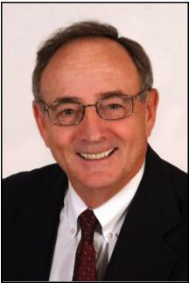

Michael Cohen, MD, Professor of Neurology and Pediatrics, State University of New York at Buffalo; Department of Neurology ; Jacob’s School of Medicine and Biomedical Sciences

Research day in the Department of Neurology is always auspicious, for the resi-dents and faculty alike. It is a time to reflect on the years spent at this University and the influence that your peers and the faculty have had on your develop-ment as sophisticated physicians.

Today, for the graduating seniors, marks a new beginning, a transition from stu-dent to fully-trained neurologic physician. I suspect the journey for many has been marked by joy and stress, doubt and attribution and above all pride, in your accomplishment.

As a faculty, we are delighted at your development and the list of all of your accomplishments. Your group has been recognized as teachers, authors and caring physicians.

As you move on in your life's journey, remember well the gifts given to you by this University. Continue to study and learn, honor your patients and as demon-strated to us, your teachers, "be all you can be".

We will miss you but recognize that we have helped you prepare for the future. Do well and stay in touch!

Michael E. Cohen, MD, FAAN, FANA, is a Professor of Pediatrics and Neurology. Dr. Cohen was Chair of the UB Neurology Department from 1983-2000. He is a past President of the Child Neurology Society, The Association of Child Neurolo-gy Professors and past President of the Section of Child Neurology of the Ameri-can Academy of Neurology. He has been responsible for several of the all-day child neurology courses given at the annual meeting of the academy. He was a member of the organizing committee of the ABPN for neurodevelopmental neurology and has served on the writing committee for recertification for child neurology of the ABPN. His research interests have been primarily in neuro-oncology.

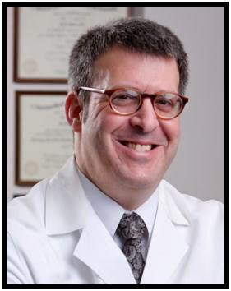
Gil I. Wolfe, M.D., FAAN Chair, Department of Neurology University at Buffalo;
Jacob’s School of Medicine and Bio-medical Sciences.

Welcome to the Michael E. Cohen Resident Research Day; an an-nual event held by the University at Buffalo’s Department of Neu-rology staged in recognition of research projects conducted by our residents and fellows.

Our research day represents the culmination of months and even years of meticulous work by our neurology trainees. This work is now subjected to peer scrutiny and competition for awards.

Moreover, the research day recognizes the involvement of our faculty and fellows in the mentorship of residents. Experience and lessons learned are passed from each generation of physician re-searchers to the next in just this way.

Through the years, graduates of our program have repeatedly confirmed the invaluable experience of their participation in the Research Day. Their comments express an increased apprecia-tion not only for the clinical research process itself but also for the positive impact it will always have on their clinical careers.

Today's presentations continue an established tradition of aca-demic excellence. Please join the entire UB Department of Neu-rology in commending each resident and fellow for the innova-tion, scope and execution of their projects. On display are analyt-ical skills, judgment and integrity. Please also accept my sincere appreciation to all of you for contributing to and sharing in the day's events.

Best, Dr. Wolfe

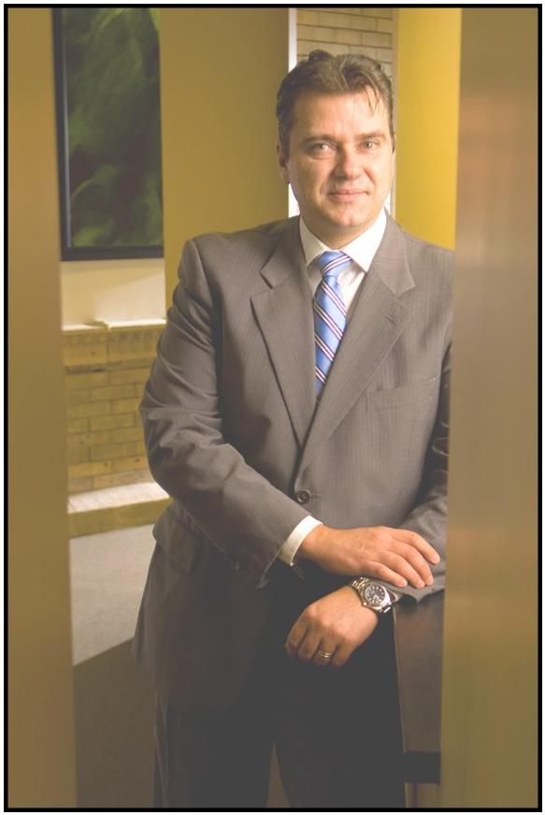
Robert Zivadinov, M.D., Ph.D.,
FAAN, FANA, FEAN
Resident Research Training Pro-

gram Director
Professor of Neurology,

State University of New York at Buffalo; Department of Neurology Jacob’s School of Medicine and Biomedical Sciences BNAC Director
MR Director of Imaging; CTRC

This is the thirteenth year of our expanded Resident Research Training Program and the scope as well as range of the projects presented to-day undoubtedly display resourcefulness, determination, commitment and knowledge.

Whether our presenters’ vocation leads them towards clinical work or further research, they are all true intellectuals, having shown the judg-ment, perception and motivation that will guide them proficiently in years to come. I commend each and every one of them for a job well done.

It has been my primary purpose in these last few years to promote as well as facilitate such a development in project diversity. As you see in our program today, although we continue to encourage study in the fields of our core and strength areas—multiple sclerosis and stroke—we have also increased the number of projects that explore other neurolog-ical disorders and diseases.

With these additional advancements, we hope to “pave the way” to the next level of research distinction. Projects that are progressively far-reaching and innovative will considerably advance the careers of our new physicians as well as enhance both the importance and notoriety of our Neurology Residency Program. What a magnificent endeavor to be a part of!

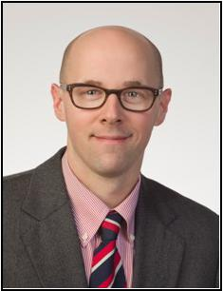

Nicholas J. Silvestri, M.D.,

Assistant Professor of

Clinical Neurology

Program Director,

Adult Neurology Residency,

State University of New York at

Jacob’s School of Medicine

and Biomedical Sciences

It gives me great pleasure to see yet another class of resi-dents graduate from our training program. Over the past three years, we have watched these individuals grow into outstanding clinicians, teachers and scientists. I am certain that they will continue to make us proud. As the end of an-other academic year approaches, I am inspired by the en-thusiasm and fortitude of our trainees. I would like to thank

all of our residents for their hard work and dedication. I

would also like to thank the faculty for their devotion to teaching and their support of the training program. Finally, I would like to acknowledge the outstanding efforts of Ms. Eva Tamoga and Mr. Tom Bellanca who work tirelessly in support of the program.

A native of Western New York, Dr. Silvestri has been on faculty in the De-partment of Neurology since 2009 and Program Director of the Adult Neu-rology Residency since 2011.

Safety of Intravenous Thrombolysis for Acute Is-chemic Stroke in Patients Taking Warfarin with Subtherapeutic INR

Aurangzeb Memon, MBBS, Ashkan Mowla, MD

State University of New York at Buffalo; Jacob’s School of Medicine and Biomedical Sciences Department of Neurology
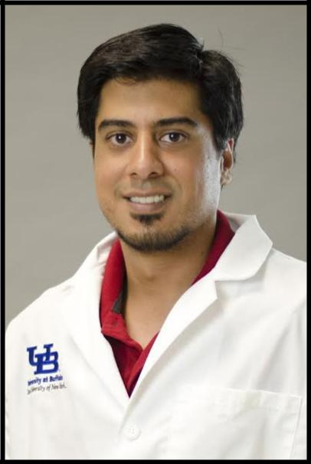

Born and raised in Toronto, Canada, Aurangzeb relocated to Kara-chi, Pakistan at the age of 17, where he completed his pre-medical and medical training. After completing a preliminary year in inter-nal medicine, he continued his post-graduate training in Neurology and is currently a PGY4 and chief resident for the neurology pro-

gram. His research interests include cerebrovascular disease and

epilepsy. Dr. Memon will pursue a vascular neurology fellowship with UT Houston after graduating from the adult neurology residen-cy program here at SUNY Buffalo.

Introduction:

Current AHA/ASA guidelines allow the use of intravenous rtPA in warfarin-treated acute ischemic stroke (AIS) patients with INR of ≤1.7. Concerns remain about the safety of intravenous rtPA ( IV rtPA), as value 1.7 wasn’t determined through randomized trials and data is controversial.

Objectives:

To evaluate the rate symptomatic intracranial bleeding ( sICH) and also out-the come of AIS patients who are taking warfarin and have sub-therapeutic INR and compare with non-warfarin patients. Also to evaluate the rate of sICH and outcome in warfarin-treated AIS patients receiving intravenous rtPA with different INR ranges.

Methods:

We retrospectively looked into the database of patients who received intra-venous rtPA for AIS from January 2006 till March 2015 (834). We identified pa-tients taking Warfarin on the days prior to presentation (55). One patient ex-cluded for INR being elevated beyond the INR range acceptable for IV rtPA treatment. Due to differences in sample size (54 vs 779), Warfarin group was matched by case-control manner with 54 non-warfarin patients with similar independent risk factors for sICH (age, admission NIHSS, history of diabetes). This eliminated need to adjust for covariates. Multiple variables associated with outcome and safety and also frequencies of good outcome and sICH were calculated for each group and compared. Also, Warfarin group was dichotomized based on INR (1-1.3 vs 1.3-1.7) and safety and outcome measures were compared between these groups.

Results:

54 patients (15.4%) identified taking Warfarin, INR 1-1.7. No significant differ-ences were found between warfarin and non-warfarin groups in terms of fre-quency of good outcome on discharge or occurrence of sICH. Also there was no group difference regarding frequency of patients with good outcome and rate of sICH between subjects on warfarin with an INR 1.3-1.7 and those with INR less than 1.3

Conclusion:

Our results suggest that IV rtPA doesn’t increase risk of sICH in Warfarin treated patients with INR<1.7 and there is no significant difference in terms of good outcome between patients on warfarin compared with those who are not on warfarin.

Conflict of Interests:

Aurganzeb Memon, MBBS has no conflicts of interest. Dr. Ashkan Mowla has no conflicts of interest.

Disclosures:

None of the authors have anything to disclose that is relevant in regards to this study.

IRB Approval: 3/7/2016—3/6/2017 via UB.

Will my patient bleed?? – Clinical and Laboratory fac-

tors predisposing to risk of Intracerebral Hemorrhage

after Thrombolysis in Acute Ischemic Stroke

Haris Kamal, MD, Co– Chief Resident

Ashkan Mowla, MD, FAHA

State University of New York at Buffalo; Jacob’s School of Medicine and Biomedical Sciences; Department of
Neurology

Dr. Haris Kamal completed his medical school with Honors at Yerevan State Medical University, Armenia in 2009. Subsequently, he completed a year of rotating medical internship at a state hospital in New Delhi, India. Dr. Kamal joined UB Neurology Residency after completing his medical internship at UB Internal Medicine in 2013.

Haris enjoys doing clinical research and has co-authored 11 publications in peer-reviewed journals. He has presented more than 20 research abstracts as well as 3 platform presentations at National and International Conferences during the course of his residency including winning four resident research awards. Haris has also co-authored 6 book chapters on different topics in Neu-rology and currently is a reviewer for multiple peer reviewed journals.

Dr. Kamal is a member of the Gold Humanism Honor Society and has served as the Co-Chief Resident for this academic year. Besides being the UB Residents Committee representative, he also was a member of the Resident Leadership Advisory Committee at Kaleida.

His research project today has been presented at the AAN and is in the pro-cess of final revisions of the manuscript.

During his leisure time, Haris enjoys reading about history, biking and travelling. Dr.Kamal will be a Vascular Neurology fellow at The University of Texas at Hou-ston and plans to pursue an Interventional Neuroradiology training in the fu-ture. He has interests in the pathophysiology of ischemic stroke, endothelial dysfunction as well as perfusion imaging of hyper-acute strokes using different modalities.

BACKGROUND

Factors associated with hemorrhagic conversion (HC) after Intravenous thrombolysis with rtPA (IVT) for Acute Ischemic Stroke(AIS) remain nebulous despite advances in our knowledge of AIS. This is a comprehensive study investigating clinical and laboratory data influencing and predisposing to HC in AIS patients receiving IVT or IAT.

METHODS

We retrospectively reviewed the medical records of patients who re-ceived IV tPA for AIS at our comprehensive stroke center from 01/2006 till 09/2015. Besides age, gender, NIHSS, history of DM, history of atrial fibrilla-tion, we gathered their laboratory data including INR, lipid panel, serum albumin, serum creatinine, hemoglobin A1C , and admission blood glu-cose. Post-thrombolysis brain imaging was reviewed to evaluate for any symptomatic ICH (sICH). The mean values of above mentioned laboratory data were compared between the group with sICH and non-bleeders. A t -test and logistic regression was performed. Univariate and multivariate logistic regression were performed to evaluate the association of the clini-cal and laboratory findings with presence of sICH.

RESULTS

Of 794 subjects in this study 51 (6.4%) had sICH. In univariate analysis, pa-tients who had sICH had significantly higher NIHSS on admission (14.2±5.4 vs 11.2±6.5, p<.001), LDL (113.3 ±36.9 vs. 101.8±38.2, p=.032), HbA1c (6.9±2.3 vs. 6.1±1.3, p=.003) and lower levels of Albumin (3.5±0.4 vs. 3.9±0.5, p<.001) compared to subjects with non-bleeders. Furthermore, a higher preva-lence of history of DM (34.8% vs. 22.2%, p=.020) and Afib (19.7% vs. 10.7%, p=.028) was found in subjects presenting with sICH. There were no signifi-cant group differences regarding age, sex, total cholesterol, blood glu-cose on admission, Creatinine or INR levels (all p>.05). After adjusting for covariates, (Lower) Albumin levels, (higher) LDL, (higher) Total Cholesterol and (higher) HbA1c were significantly associated with an increased risk for sICH development

CONCLUSION:

Multiple laboratory data including lower endogenous albumin levels and higher HbA1C have shown to predispose to a higher risk of HC after IV thrombolysis. Prospective studies are needed to corroborate these find-ings.

IRB Approval: #MODCR00000144 via UB

Conflict of Interests:

Neither Dr. Haris Kamal or Dr. Ashkan Mowla have any conflicts of interest to declare.

Disclosures:

Neither Dr. Haris Kamal or Dr. Ashkan Mowla have any relevant disclosures to make in regards to this study.

Exploration of Antiepileptic Regimens as a Con-

tributing Factor in SUDEP

Lindsay Dudeck, MD, Caila Vaughn, Ph.D., & Osman

Farooq, M.D.

State University of New York at Buffalo;

Jacob’s School of Medicine and Biomedical Sciences

Department of Child Neurology
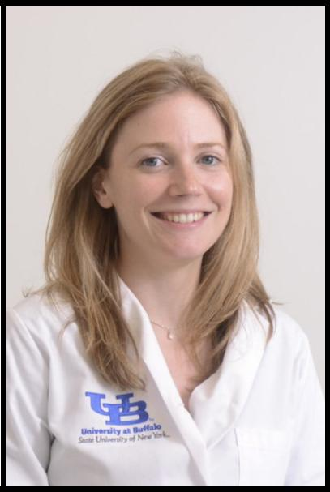

Lindsay was born and raised in Buffalo, New Yorki and attended col-lege at the University at Buffalo where she studied English literature. Af-ter completing graduate school at Columbia in NYC, she moved back to Buffalo where she completed medical school and chose to pursue a residency in pediatric neurology. Her general pediatric residency train-ing was done in Syracuse, New York, followed by a brief stint at Tufts Child Neurology Department before moving back to Buffalo to com-plete her neurology training. After graduation she plans to move to North Carolina to begin her career.

Introduction

Sudden unexpected death in epilepsy (SUDEP) is a rare but traumatizing cause of death in patients with seizure disorders. No definitive mechanism responsible for the demise of these patients is known, however theories revolve around the concept of cerebral dysregulation of cardiorespiratory function, or an alteration of central electrochemical pathways trig-gered by seizure activity, which leads to the shutdown of vital autonomic functions. Several risk factors for SUDEP have been identified, including higher frequency of seizures and polypharmacy. While polypharmacy may be a marker of a physician’s attempt to control refractory epilepsy, it is curious that many antiepileptic medications act on the same elec-trochemical substrates that regulate cardiac function and central respiratory drive. Alt-hough no single medication has been conclusively linked to a higher risk of SUDEP, we theo-rize that some combinations of antiepileptics might predispose the patient for seizure-related autonomic suppression leading to sudden death.

Methods

A retrospective chart review of deceased epilepsy patients within the neurology depart-ment affiliated with the University of Buffalo, specializing in the care of pediatric, adoles-cent, and young adult neurology patients was conducted. The goal of this review was to catalog demographic and clinical characteristics of the deceased patients as well as as-sign a cause of death. Mortality was classified as either SUDEP, epilepsy-related, or non-epilepsy-related. Analysis of specific antiepileptic regimens was undertaken to determine if a particular medication combination was associated with death due to SUDEP as opposed to death from other causes.

Results

Twenty-five deceased epilepsy patients, aged 7 months through 28 years at the time of their deaths, were included for review. Patients studied carried a diagnosis of epilepsy from any cause and died between 2009 and 2016. Of these, eight patient deaths (32%) were classified as SUDEP. As a cause of death, SUDEP was similar in our male (31.3%) and female patients (37.5%). Average age of death was similar in the SUDEP and non-SUDEP categories at 14 and 15. 3 years respectively. Caucasian patients made up the majority of our cohort and the rate of death from SUDEP in white patients was 21.7%. African American patients made up the second largest group in our cohort and the rate of death from SUDEP was 50%. Primary generalized seizure semiology (62.5%) was found at a higher percentage in the SUDEP category as opposed to focal onset with secondary generalization (37.5%). Sympto-matic epilepsy patients were less likely to die of SUDEP causes (21%) as opposed to crypto-genic epilepsy patients (80%) (p=0.033). Review of the SUDEP category patient medications as compared to those in the non-SUDEP group revealed the combination of levitiracetam and lamotrigine to be found only in the SUDEP group.

Conclusions:

It is possible that a combination of lamotrigine and levitiracetam can predispose patients with epilepsy to SUDEP. Statistical significance of this study was limited due to the small num-ber of patients within the cohort. While no definitive conclusions can be drawn, further re-search into drug combinations and SUDEP risk, specifically lamotrigine and levitiracetam, within a larger patient population is warranted. Advancements in genetic research of cryp-togenic epilepsy are needed to determine if these patients are indeed at higher risk of SUD-EP.

IRB Approval: STUDY00000368

Conflict of Interest: Neither author has any to declare.

Disclosures: Neither author has any disclosures to make relevant to this study.

Predictors of Outcome of Acute Ischemic Strokes Caused by Basilar Artery Occlusion Treated with Acute Reperfusion Therapy

Adnan Khan, MBBS

Ashkan Mowla, M.D.

State University of New York at Buffalo; Dept. of Neurology

Jacob’s School of Medicine and Biomedical Science
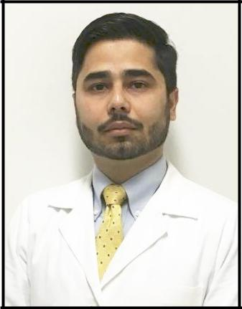

Dr. Adnan Khan is a graduate of the King Edward Medical University, Lashore, Pakistan. He received his MBBS degree in 2007. After grad-uation, he worked for two years in his home country as a Medical Of-ficer. Dr. Khan came to the United States in 2011 and was hired by

Dr. Bianca Weinstock-Guttman to do MS Research. He worked on

numerous projects. He helped to develop a more personalized mod-el for a patient-tuned treatment selection for our MS patients as part of the DICER study. He also worked on determining risk factors that may predispose patients to MS via a study of bariatric surgery pa-tients who have MS.

Background:

Basilar artery thrombosis (BAO) is a rare cause of stroke. Currently there is limited data on the best modality to treat strokes caused by BAO. There are very small number of patients with acute BAO strokes in the pivotal IV tPA and Intra-arterial thrombolysis trials (NINDS, ECASS, MR CLEAN, SWIFT PRIME).

Objectives:

To evaluate the clinical and radiological factors associated with outcome in the acute strokes caused by acute BAO who have re-ceived IV tPA, or Thrombectomy or combination of both in our comprehensive stroke center.

Methods:

This is a retrospective, hospital based study. We looked retrospec-tively into patients records that received acute reperfusion therapy for acute ischemic stroke at our center. The list was obtained from the stroke database, Kaleida Health New York State GET WITH THE GUIDELINES database (>800 patients). We compared different clini-cal and radiological variables associated with outcome in those patients.

Results:

A total of 24 patients met our criteria. We have a total of 11(45.8%) subjects who had a good outcome (mRS 0-2). Mortality rate in 3 months was 25 %. No patient developed sICH in the first 24-36 hours post treatment. Of those with good outcome, 9 (81.8%) were treat-ed with thrombectomy (p=0 .105). 15 patients were treated with just thrombectomy (including 4 who received IV tPA + thrombecto-my), and out of those 15, 9 (60.0%) had a good outcome com-pared to just 2 (22.2%) out of the 9 subjects who received only IV tPA (p=0 .105). Female Sex was the only predictor of good out-come among others (p=0.017). Mortality was not associated with the treatment type (p= 0.465).

Conclusions: Among different variables, Female Sex was the pre-dictor of good outcome. While our results would suggest that treat-ing patients with thrombectomy is more beneficial compared to IV tPA alone, the difference did not reach a statistical significance. Our result should be interpreted cautiously in the lieu of a small sample size given the rarity of this condition.

IRB: Submitted to UB.

Disclosures/COI: None of the authors have anything to disclose or conflicts of interest.

Maternofetal Risk Factors, Presentation and

Long Term Outcome of Neonatal Stroke

Farid Din, MBBS

Drs. Osman Farooq & Thomas Langan

University at Buffalo; Dept. of Neurology

Jacob’s School of Medicine and Biomedical Science
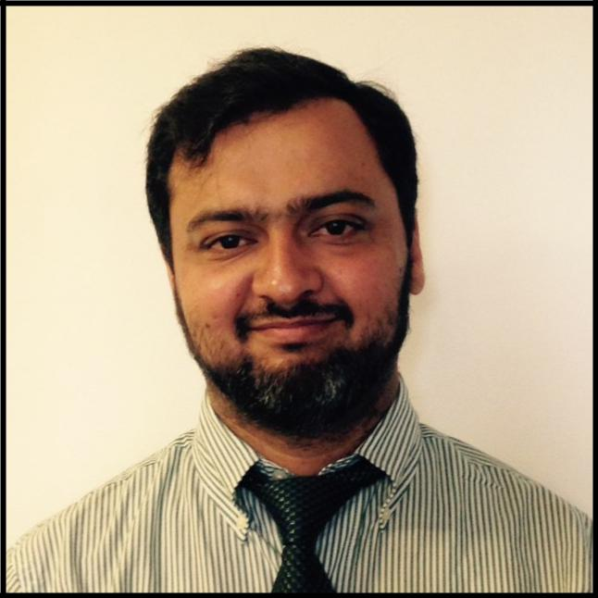

Dr. Farid Din graduated from AIMC Pakistan, completed his residency in 2008 and worked in Oman until May of 2011. He started his residency at UB in 2011 and is now doing his Pediat-ric Neurology training. His biggest achievement is an Award of best physician in the last 25 years given by The Ministry of Health Oman.

Dr. Din likes to spend time with his family, cook and to play cricket.

Objective:

The objective of this study was to highlight the maternofetal risk factors, clinical presentation and long term outcome in neona-tal ischemic and hemorrhagic stroke.

Methods:

This was a retrospective study approved by the CYIRB at WCHOB. All neonates (1- 28 days old) who presented between 2002–2012 with the diagnosis of intracranial hemorrhage (intraparenchymal, intraventricular, subdural, subarachnoid) and ischemic stroke diagnosed on MRI were enrolled in this study.

Results:

63 neonates were included in the study (54 % boys). Prematurity 26(45%)and low birth weight 19(33%) were most common neo-natal risk factors while smoking 13(23%), drug abuse 9(16%) and preeclampsia 6(11%) were the most common maternal risk fac-tors. 41(65%) patients presented with seizures while the second most common presentation was apnea and bradycardic spells 9 (14%). The follow-up period ranged from 4 months to 68 months (mean 13.1 months). Upon long term follow up, per-centages of cerebral palsy, global developmental delays and refractory seizures were 12.6 %, 9.5 % and 6.3 % respectively. 42 patients (72%) had no long term complications. Two patients in our cohort died secondary to non-neurological post-surgical complications in the setting of significant prematurity.

Conclusion:

Although neonatal stroke most commonly presented with sei-zures, the incidence of long term refractory epilepsy is very low. Overall neonatal stoke caries low morbidity and mortality, and patients exhibited favorable outcomes.

Conflict of Interest: The authors have nothing to declare.

Disclosures: The authors have nothing to disclose in relation to this study.

IRB Approval: Completed 9/1/2015

Predictors of Career and Academic Success in Ado-

lescent and Early Adult Multiple Sclerosis”

Emily Langan, MD; Pediatric Neurology Resident Research Mentor: Dr. Bianca Weinstock-Guttman

University at Buffalo

Jacob’s School of Medicine and Biomedical Sciences

Department of Neurology
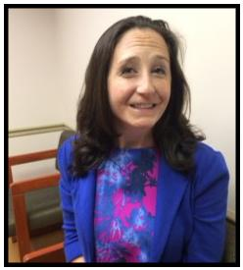

Emily Langan majored in neuroscience major at Brown University. She then attended medical school at UB School of Medicine and Biomedical Sciences and went on to complete the University at Buffalo Pediatrics Residency. Emily then pursued a year of train-ing in Pediatric Cardiology at Strong Memorial in Rochester, New York and two years of Neurology training at The Cleveland Clinic before finally returning home to complete her last year of Child Neurology training here in Buffalo. She is thrilled to work in the wonderful Neurology department here!

Background:

Multiple sclerosis is a devastating neuro-inflammatory disease caus-ing various motor, cognitive and visual problems. This condition of-ten affects young adults and adolescents at critical stages of their education or early careers. But the specific effects of MS upon ca-reer and academic outcomes in adolescents are incompletely understood.

Objectives:

To investigate the effect that of this illness has upon these out-comes in young patients.

Methods:

To perform retrospective chart reviews on MS patients between 18 and 25 years of age followed at the MS Center in Buffalo New York. We will also administer prospectively questionnaires to patients and to the siblings of these MS patients. We will collect data on a wide range of factors including disease severity, demographics, socio-economic factors such as parental academic and work history, and lifestyle factors such as smoking and exercise habits. We will describe and then analyze this data to determine which factors are associated with or are predictive of academic and vocational achievement in MS patients. Further, we will examine patient satis-faction with these career and educational achievements. Finally, we will compare educational and vocational achievement and satisfaction in MS patients with that of their siblings.

Expected results:

We expect to find that medical factors such as disease severity will correlate with lower educational and career achievement, and also with less satisfaction in these arenas. Additionally, we antici-pate that socioeconomic factors such as parental educational achievement, and lifestyle factors such as exercise will be predic-tive of academic and vocational performance. Finally, we predict that when compared to their siblings, MS patients will have lower educational and career achievement, and less satisfaction with this achievement.

IRB: Application submitted and is pending with UB.

Conflict of Interest: Neither of the authors have any conflicts of in-terest to report in regards to this study.

Disclosure: Neither of the authors have any disclosures to make in regards to this study.

Safety and efficacy of intravenous thrombolysis in acute ischemic stroke patients over 80 years who were treated in the 3 to 4.5 hr time window after symp-tom onset

Ashish Arora, MD1, Navdeep Lail, MD1, Robert N. Sawyer, Jr., MD1, Marilou I. Ching, MD1, Christopher Deline, MD1, Zaheerud-din Babar Cheema, MD1, Anne Marie Crumlish1, Ashkan Mowla, MD1.

1Department of Neurology, Gates Vascular Institute, Buffalo General Hospital, Jacobs School of Medicine and Biomedical Sciences, Uni-
versity at Buffalo, NY. USA
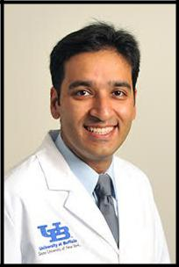

Ashish is a PGY-3 resident at the UB Neurology residency program. He was born in one of the most populous cities of the world, Delhi, India. He grew up in the suburbs of Delhi and went on to obtain his medical degree at Kasturba Medical College, Mangalore, India. He then moved on to a research fellowship in neuroimaging at Partners MS Cen-ter, Brigham & Women’s Hospital of Harvard Medical School in Boston, where his work included studying the correlation between data obtained from high resolution MRI scans of the brain and spinal cord with metrics of physical and cognitive disability in patients with MS. He has been a part of many national and international presentations, abstracts and peer-reviewed publications. He has won travel awards to the AAN as well as ECTRIMS/ACTRIMS combined meetings.

Ashish started his internship at UB in 2013 and has been a neurology resident from 2014. He is one of the chief residents for the in-coming academic year. In his residency train-ing, other than the clinical training, he is involved with the PGY-3 class QI project that has been granted the GME QI award from the UB office of GME as well as clinical re-search involving the Kaleida Health stroke database.

Introduction:

Intravenous-rtPA (IV-tPA) is standard-of-care for acute ischemic stroke (AIS) patients presenting within 3 hours of symptom onset based on NINDS trial (1995). There was no upper limit of age for sub-jects and only included those within 3-hours of symptom onset. ECASS-III trial (2008) studied efficacy of IV-rTPA in patients within 3-4.5 hour window but only included subjects < 80-years-old. Both studies showed neurologic improvement in treatment group but also showed increased intra-cerebral bleed compared to placebo. Data on efficacy and safety of IV-rtPA in patients >80-years-old in 3.0-4.5 hour window is scant..

Objectives:

To evaluate safety and efficacy of IV-tPA in patients >80-years in 3– 4.5 hours of symptom onset.

Methods:

We plan to retrospectively analyze KaleidaHelath NYS “GET WITH THE GUIDELINES” Stroke database for patients who received IV-tPA for AIS from January 2006-September 2015 (~834 patients) . Patients >80-years-old who received IV rTPA in the 3-4.5 hour window from symptom onset (~70 patients) will be identified. We will obtain de-mographic, clinical (vitals, NIHSS etc), clinical outcome [(modified Rankin scale (mRS)], safety data (intracerebral bleeds post IV-tPA datas) and if intraarterial procedure was performed.

Data Analysis:

We will look at the absolute number of intracranial bleeds post IV-tPA (safety measure) and mRS on discharge and 90-days (efficacy measure) as outcome measures and we will compare the safety and outcome of IV-tPA in this group of patients with patients less than 80 who received IV-tPA in the same time window period. We will adjust for covariates (e.g. NIHSS/timing of IV-tPA/prior anticoag-ulant/antiplatelet use etc.). Basic demographic and clinical measures will be compared using chi-square and independent t-tests. Covariates for adjusted analysis will be based on significant (p<0.05) group differences. Regression modeling will be used to ad-just for covariates.

Expected Results:

Identify the safety and efficacy of IV-tPA for AIS in patients above 80 when treated 3.0-4.5 hours since symptom onset.

Disclosures/COI: None of the authors have any conflicts of interest or dis-closures to make in regards to this study.

IRB Approval #MODCR00000144

Analysis of Heart Rate Variability during

Nocturnal Seizures

Hao Cheng MD, Sarah Muldoon PhD, Arie L. Wein-

stock MD,

University at Buffalo; Dept. of Neurology

Jacob’s School of Medicine & Biomedical Science
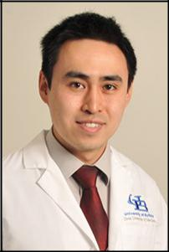

Dr. Cheng was interested in sciences since childhood growing up in Ottawa, Canada. He went on to study electrical engineering at The University of Illinois, Urbana-Champaign for college. Afterwards, he worked for a few years at Microsoft on the Windows operating system prior to going to New York University for medical school. He loves Neurology given the complexity, research potential and his background, which bought him to this Neurology Residency here at The University at Buffalo.

Abstract:

This is a retrospective study looking differences in heart rate (HR) changes from seizures occurring while patient is awake and while patient is sleep-ing. The study will enroll patient who were admitted to the epilepsy moni-toring unit, having generalized seizures or complex partial seizures during both wakefulness and while asleep. For each seizure detected on EEG, the single lead EKG will be analyzed to quantify change in HR, variability of HR, and time to onset relative to EEG seizure onset. Using t-test with alpha at 5%, this study will compare the changes in heart rate characteristics be-tween the seizures that occur when the patient is awake and while the patient is sleeping. This study will also do a subgroup analysis between the different seizure types if sample sizes allow, to see the impact it has on vari-ability of heart rate between sleep and awake states.

Background:

Sudden unexpected death in epilepsy (SUDEP) is an important cause of death for patients who are suffering from poorly controlled seizure disor-der. Studies have shown that nocturnal seizures can be an independent risk factor for SUDEP. Controlling nocturnal seizures may be important in preventing sudden death. Vagal nerve stimulators (VNS) have been a rel-atively new therapeutic option for patients with refractory epilepsy. Nu-merous studies have looked at HR variability during seizures,,. Current gen-eration of VNS is able to detect heart rate (HR), and use that data to pre-dict or help detect the occurrence of seizures. These devices have been employed to help abort seizures, should it detect a seizure occurring. Alt-hough there are two retrospective study that looked at autonomic chang-es (HR, RR) pre vs post ictal, and HR changes of partial seizures during sleep, it will be useful determine, among patients with nocturnal and day-time seizures, if the seizures occurring during sleep have similar characteris-tics of autonomic dysfunction as their daytime seizures.

Objectives:

Assess if seizures occurring during sleep presenting with similar heart rate changes as seizures occurring during the day, in terms of HR changes, HR variability and time to onset of heart rate changes

Differences in heart rate changes shown in this study can provide more clues on the pathophysiology of SUDEP with nocturnal seizures

These changes can have implications on patient with refractory sei-zures requiring VNS

These heart rate changes may provide insight on the pathophysiology of autonomic changes during seizures

Hypothesis:

Experimental hypothesis: Seizures occurring during sleep will have dif-ferences in heart rate changes compared to seizures occurring during wakefulness

Null hypothesis: No significant differences in heart rate variability be-tween seizures occurring during sleep and while awake

IRB Approval Submitted: ID: 860369-1. No disclosures or conflicts of interests.

Incidence, predictive factors and efficacy of treat-ment of epilepsy in Ischemic stroke patients who re-ceive IV t-PA with or without mechanical thrombectomy.

Rabia Ghazi, MBBS; Navdeep Singh Lail, MBBS; Ping Li, MD,

MSc; Ashkan Mowla, MD, FAHA

University at Buffalo, Dept. of Neurology;

Jacob’s School of Medicine and Biomedical Science
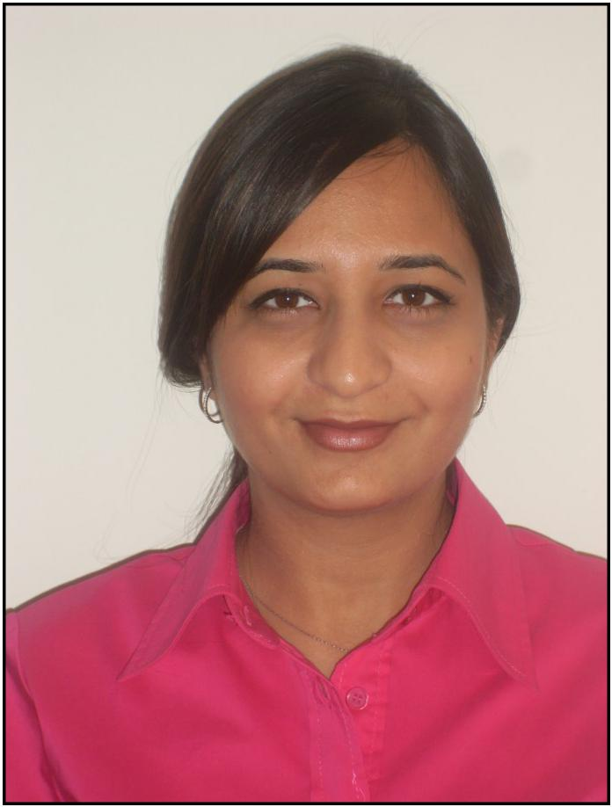

Dr. Rabia Ghazi is currently a PGY III Neurology resident at the Universi-ty at Buffalo. She graduated from King Edward Medical University in Lahore, Pakistan. She moved to Buffalo, New York in 2010 after getting married, leaving her family back home. She started to work in re-search in the field of neurology at The Jacobs Neurological institute and worked with some of the nicest and smartest neurologists who inspired her to decide that she would like to follow their footsteps and chose to become a Neurologist. Rabia is currently living in her beauti-ful house in Clarence, New York with her husband who is a family physi-cian. She enjoys cooking and spending leisure time with her family. whenever she can.

Objectives:

In this study we will evaluate a large cohort of ischemic stroke patients who received IV tpA and/or mechanical thrombectomy in our compre-hensive stroke center with data available from January 2006 to August 2015. The focus will be to determine the incidence and predictors of early vs late onset of unprovoked seizures in this patient population and the functional outcomes based on the Modified Rankin Scale (mRS) upon dis-charge. Use of anti-seizure medications and their efficacy to control the recurrent seizures will also be assessed. All the information will be gathered at a single center that will increase the uniformity of information and mini-mize the information bias.

Methods:

We plan to retrospectively study ischemic stroke patients who received acute perfusion therapy from January 2006 to March 2015 (over 800 pa-tients) obtained from the Kaleida Health New York State GET WITH THE GUIDELINES database. We will gather the following information for each of these patients: Demographic data, duration between symptom onset to IV tPA and/or mechanical thrombectomy, home medications with focus on anti-convulsant medications, antiplatelets and statins, head CT result prior to, and after IV tPA and/or mechanical thrombectomy, brain MRI findings during admission, location of the infarcts, vessel territory involved, NIH Stroke Scale (NIHSS) at admission, incidence and recurrence of sei-zures, EEG findings, NIHSS at discharge and mRS at discharge.

We will determine the rate of seizures after IV tPA and/or mechanical thrombectomy administration in this group, factors influencing the seizures post stroke, effectiveness of anti-seizure medications and use of mRS for functional outcome on discharge.

Data Analysis:

Data analysis will be carried out using SPSS 21.0. The sample will be based on the database of over 800 ischemic stroke patients who received IV tPA and/or mechanical thrombectomy. Out of that, the incidence of seizure disorder will be determined and selected for further analysis. Independent samples t-tests (for parametric continuous variables) and chi-square tests (for categorical variables) will be carried out to determine which clinical and demographic factors may be associated with seizures among is-chemic stroke patients who received acute treatment. Factors that will be analyzed include, but are not limited to: clinical elements such as treat-ment with IV TPA, mechanical thrombectomy (with or without IV TPA), NIHSS, use of anti-convulsant medications and their efficacy in controlling seizures.

Expected Results:

We hope to be able to delineate the incidence and clinical factors influ-encing seizures post stroke in this subgroup of patients. To date, the varia-bles found to have influenced seizures in previous studies have been lim-ited to stroke patients without any acute intervention and studying these variables in this group might guide clinicians for a better treatment plan for this subset of patients.

IRB Approval #: MODCR00000144;

Conflicts of Interest and Disclosure: Nothing to declare.

“Neuromyelitis Optica Spectrum Disorders Experience in

at a Large Western New York Multiple Sclerosis Center:

Analysis of Age, Race, and Concurrent Comorbidities and Autoimmune Diseases as Independent Predictive Risk Factors in Guiding Immunosuppressive Therapy.”

Svetlana P. Eckert-1, Channa Kolb1, Weinstock-Guttman1

1The Jacobs Neurological Institute, Department of Neurology, Univer-

sity at Buffalo, State University of New York, Buffalo, NY, USA.
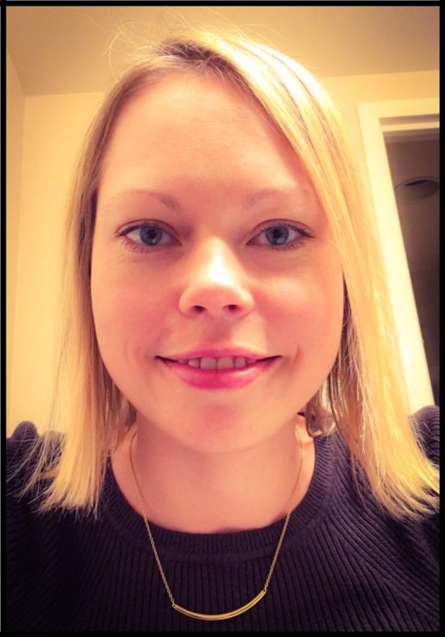

Svetlana Primma Eckert was born in Estonia, moved to the U.S. at the age of 14, after which she lived in Brooklyn, N.Y., Baltimore, M.D., and Washington, D.C. before mov-ing to Buffalo for medical school and residency. Her interest in neurology was inspired when she had to see a neurologist at a young age, and did not fade when she no longer needed to see one as a patient. At the Johns Hopkins University, she majored in Biophysics and worked in a molecular biology lab, but found her true passion while shadowing a Multiple Sclerosis (MS) specialist. After that, she briefly worked at the NIH as well, studying theneffects of increasing sleep on obesity and weight loss.

She further pursued her interest in Multiple Sclerosis and Neuroimmunology in medical school through collecting data on pediatric MS disability and lipids and recently at-tended the Masters MS and the MS Fellowship Forum at the CMSC. Svetlana hopes to pursue a fellowship in MS and Neuroimaging and is currently focusing on a different autoimmune neurologic disease, Neuromyelitis Optica, in her resident research pro-ject. Besides her interest in neuroimmunology, Svetlana enjoys yoga, cycling - espe-cially for the Ride for Roswell, and spending time with her pets: two crested geckos, two cats,and a golden retriever.

Background:

Neuromyelitis Optica Spectrum Disorders (NMOSD) is a recently devel-oped term unifying different NMO disorders which include clinical syn-dromes or MRI findings related to optic nerves, spinal cord, area postrema and other brainstem or cerebral lesions[1]. NMOSD is further stratified by serologic testing for the aquaporin-4 antibody (AQP-4-IgG). Because of highly variable presentation of NMOSD, little data exists on factors that predict disability outcomes and relapse rates and/or response to therapy in NMOSD.

Objectives:

To investigate a large population of NMOSD and explore the effect of demographic factors as well as comorbidities and concurrent autoim-mune diseases on disease progression, relapse rates and disability pro-gression with a secondary objective of comparing the efficacy be-tween different therapies in NMOSD.

Methods:

Retrospective chart review of patient records with NMOSD from the BGH/JNI inpatient and outpatient databases. Data will include de-mographics, lab data for presence of NMO IgG and other autoim-mune antibodies, MRI characteristics, OCT and PRVEP. Analyses will be performed using unpaired t-tests or Mann Whitney U-tests, Kaplan-Meier method to estimate disability outcomes and the Cox proportion-al hazards model to compare time-to-event statistics. Therapies and their timing will be compared in various groups and their effects on disability.

Results:

The results will be reported as differences between groups with com-parison categories including age, ethnicity and AQP-4 seropositivity as well as concurrent findings of other autoimmune antibodies. The effect of various immunosuppressive agents on disease progression and an-nualized relapses rates will also be reported.

Conclusions:

With a review of a large NMOSD population, we will identify factors that worsen or improve disability and outcomes in NMO disease. Look-ing at the time of initiation and type of immunosuppressive therapy we may be able to conclude that certain groups of NMOSD patients, should be risk stratified to earlier initiation of immunosuppressive thera-py to prevent worse disease progression and disability.

IRB Approval: STUDY00000449. Application submitted on 3/20/2016

Disclosures: We have no disclosures or conflicts of interest. This research will be part of a resident research project and will not receive significant out-side funding.

Conflicts of Interest: There are no current conflicts of interest to declare at this time.

Olfaction and Copy Number Variation in

Alzheimer’s Disease

Brian Trummer, M.D. and Dr. Kinga Szigeti

University at Buffalo, Department of Neurology

Jacob’s School of Medicine & Biomedical Imaging
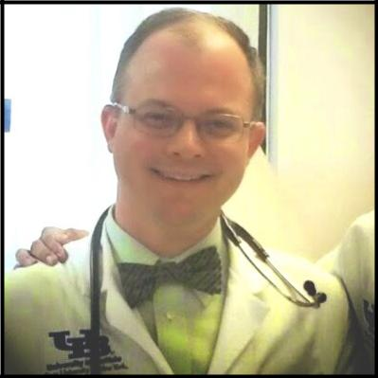

Years ago, while Buffalo, New York was hit by the blizzard of the century, Brian was born in Queens, NYC. His childhood window overlooked the Manhattan skyline, a constant inspiration as to what was capable by the human mind. Bri-an set out to deepen his understanding of the universe at Cornell University, where he met his wife, Lynnette and studied genetics and development. Later, he went off to the University of Oxford, to undertake a Masters in genomic ar-chaeology, where he studied under his mentor, Professor Ryk Ward. On return-ing to New York City, he worked at the Columbia University Genome Center for three years, developing carbohydrate microarray technology with Dr. Denong Wang. Later, Brian worked briefly at Boehringer Ingelheim Pharmaceuticals in the core lab for protein purification. His journey came full circle when he began his MD/PhD program at Buffalo in 2004 and experimented with liposomal formu-lations of kinase inhibitors with mentor Dr. Straubinger. He enjoyed the Buffalo lifestyle and was excited to continue on within the Neurology Residency pro-gram. Brian has 2 sons, Gabriel and Daniel who have been known to philoso-phize with faculty members on diverse topics ranging from scorpions to the tem-poral discrepancy between auditory and visual evoked potentials. Neither Bri-an Trummer or any of his colleagues have any conflicts of interest or disclosures to declare.

Alzheimer’s disease is the most common form of dementia and presents a significant public health issue given the burdens it places on society. Early identification of patients who are likely to develop the disease would assist in testing early disease modification therapies to preserve neurons at risk.

Olfaction may offer such an early test, as it is quick, and relatively easier to test in a practical clinical sense. While significant research has been done utilizing the absolute performance score of 40 identifiable odors on the University of Pennsylvania Smell Identification Test (UPSIT) to distinguish Mild Cognitive Impairment (MCI) and Alzheimer’s Disease patients from normal controls, novel research is beginning attempting to map odors with their respective receptors and genomic location. In this proposal, we seek to identify which of the 40 smells are more predictive in identifying MCI and AD patients. We hypothesize that a common chemical structure may exist for MCI and AD odors that my share a common structure shared in AD pa-thology. Additionally, we hypothesize that the receptors for odors prefer-entially lost in MCI and AD may share a common genomic modality, in copy number variation (CNV), %GC rich isochore the receptor is found, chromosomal location, or proximal neuronal genes to the olfactory recep-tor of interest.

Objectives and Hypothesis:

Aim 1: We hypothesize that there are specific odors that have higher pre-dictive value in distinguishing MCI and conversion to Alzheimer’s disease from normal controls.

Aim 2: We hypothesize that predictive odorants for conversion to MCI or Alzheimer’s disease share a similar chemical compound structure or chiral preference, correlating to a pathological hallmark of the disease

Aim 3: We hypothesize that the genomic location of olfactory receptors lost in MCI and Alzheimer’s disease is what distinguishes these from recep-tors preserved in MCI and Alzheimer’s disease.

Expected Results:

We expect that odor identification ability will vary among the 40 smells, with certain with specific odors misidentified with greater frequency in MCI and Alzheimer’s patients. If our hypothesis is correct regarding chemical structure of such odors share a common structural motif, this will be identi-fied in our study analyzing the chemical structures of the 40 smells and which ones sort to disease state. This would be under the hypothesis that odor molecules share a similar structure to signaling molecules, and this shared structure may identify a shared mechanism of pathological loss. Additionally, we would expect there may be a genomic association be-tween smells lost in AD and MCI in that they may exist in high or low %GC content DNA with stability based on %GC content, or that certain odor receptors lost may be in close proximity to Alzheimer’s disease. We would expect that analyzing specific odor identification performance in normal controls to CNVs in genome may link a specific odor to a specific olfactory receptor thereby increasing human knowledge.

IRB approval 7/8/2015 Titled: Genetic Study of Alzheimer Disease (NEU3081010A).

Graduation Dinner:

The Hotel Lafayette-The Greenhouse
391 Washington Street

Buffalo, NY 14203

June 10, 2016

6:00 pm

Cocktails

7:00 pm

Dinner

Adult Neurology Resident Program

Director’s Introductions and Comments:

Nicholas J. Silvestri, M.D.

Chairman’s Address:

Gil I. Wolfe, M.D., FAAN

Neurology Resident Research Program Director’s

Comments:

Robert Zivadinov, M.D., Ph.D., FAAN, FANA, FEAN

Michael E. Cohen Research Day Awards

Presentation:

Michael E. Cohen, M.D.

Graduation Ceremony for Graduating Residents &

Fellows:

Nicholas J. Silvestri, M.D., Adult Neurology Resident

Program Director;

Sarah Finnegan, M.D., Ph.D., Child Neurology Resident Program
Director;

Ping Li, M.D.; Clinical Neurophysiology Fellowship

Program Director;

Margaret Paroski, M.D., Director, Neurology Clerkship

Message from Outgoing Chief Residents:

Haris Kamal, M.D. & Aurangzeb Memon, MBBS

Message by In-coming Chief Residents:

Ashish Arora, M.D. & Svetlana Eckert, MD

9:30 p.m. - End of Reception

